ATTACHMENT E

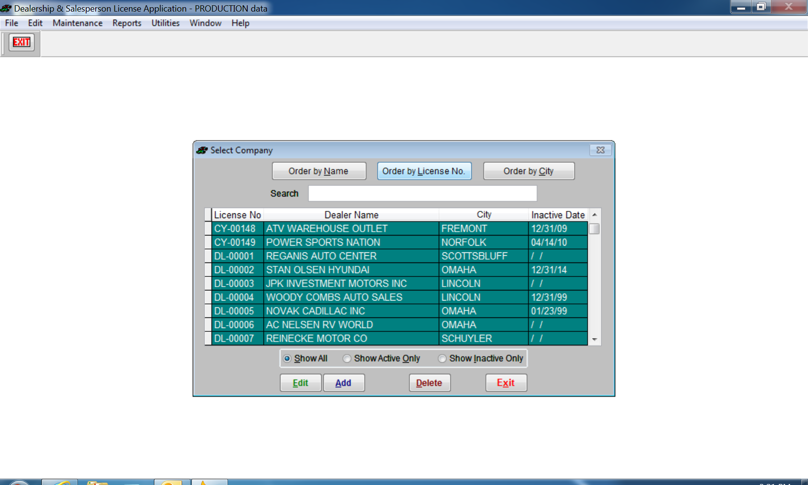
Opening screen to select company to review information for the licensed Company (active and inactive) or to Add a new company.
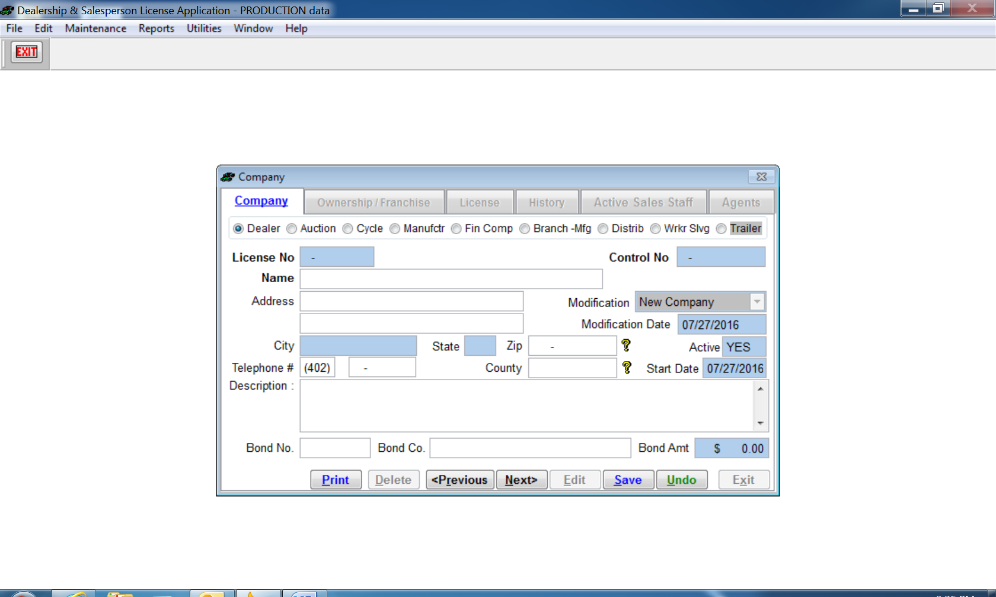
There are 9 different company licenses; the License Number is assigned according to the license type selected. Dealer, Cycle, Trailer dealers will have bond information that is entered. Sales Staff are entered on a separate form, and will be tied to the dealer by Dealer License Number.
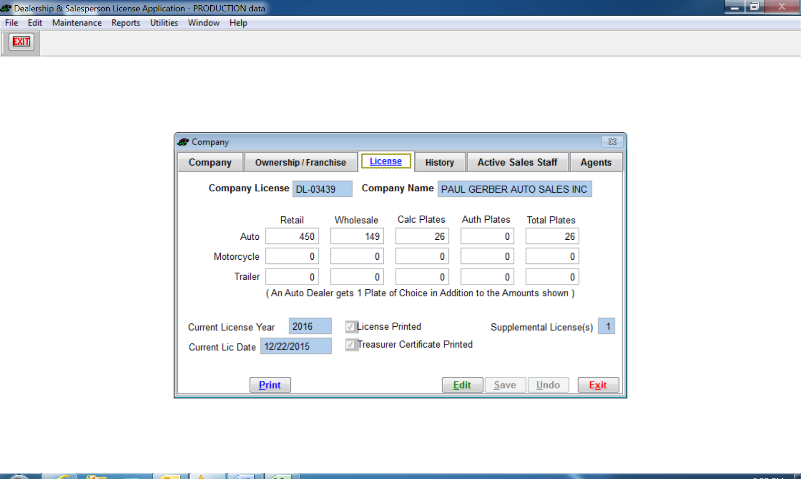
All licenses expire December 31st, annually. Nebraska Dealers and Nebraska manufacturers report on the license renewal the number of vehicles, motorcycles, and/or trailers sold or manufactured for the reporting period, this is entered into the database which calculates the number of dealer plates the dealer is allowed. The Agency may authorize additional plates, which is manually entered into the database.
Some dealers may have a Supplemental License, which prints in addition to their dealer license.
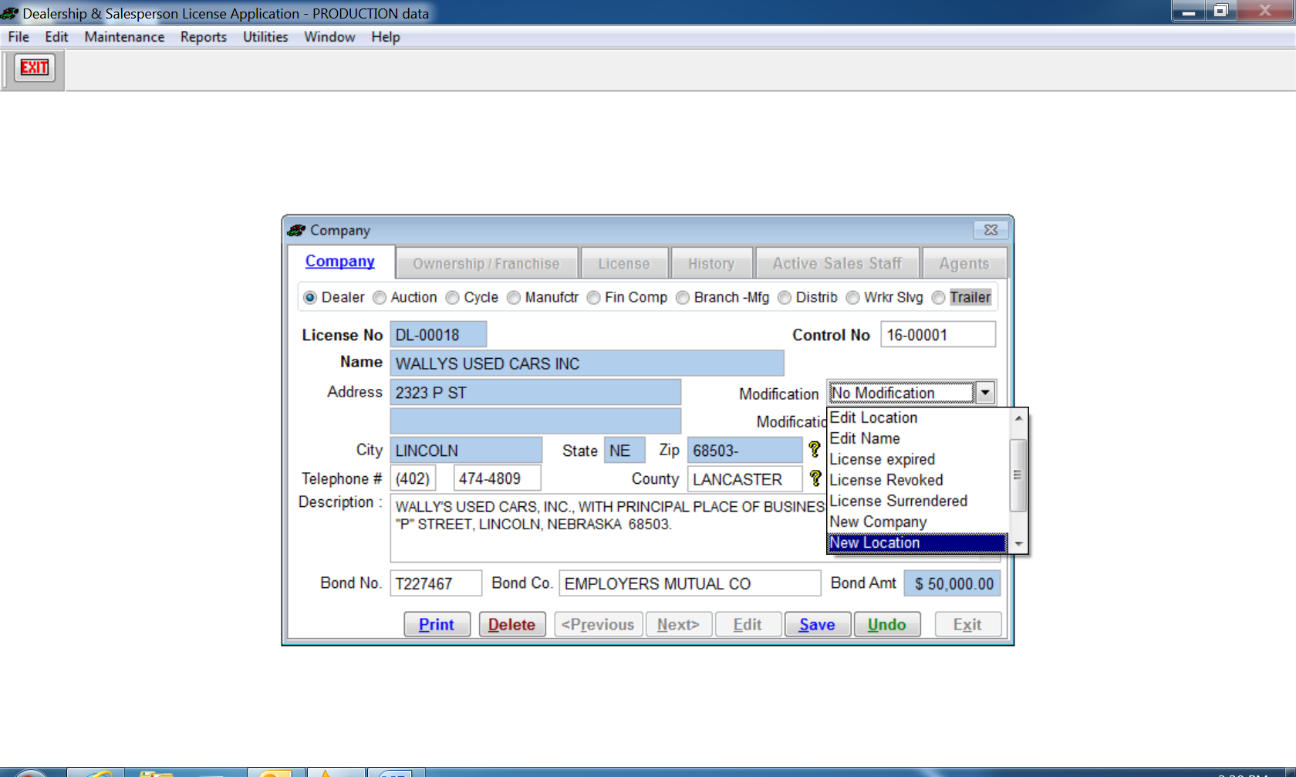
Actions or Modifications for a licensed company. The action is recorded in the company History tab (except for Edit location or Edit name).
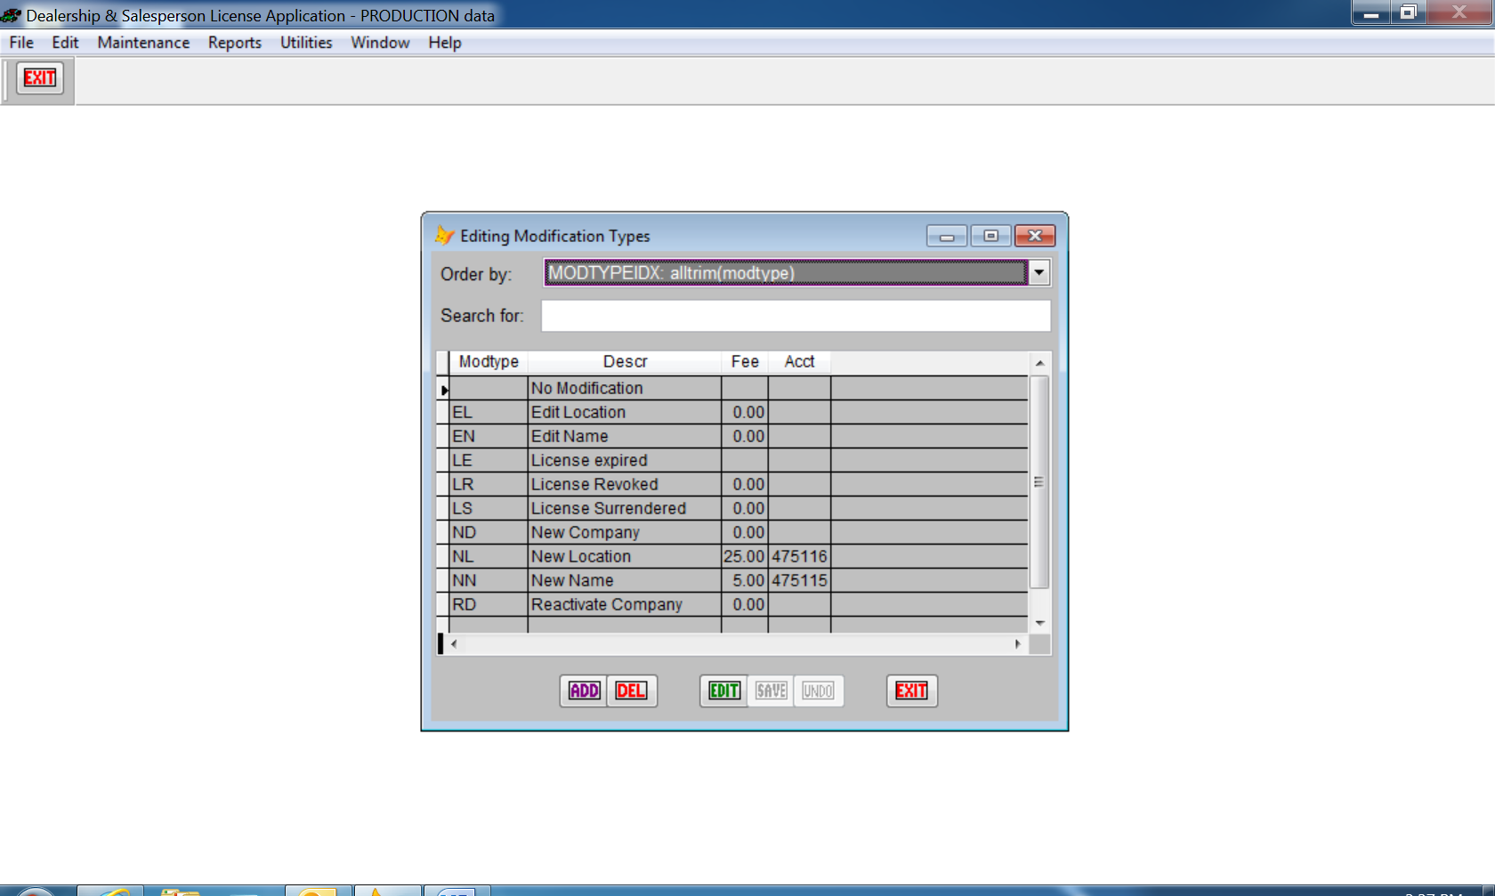
One of the Tables under Utilities: Actions or modifications for a company license. New Location and New Name have an associated fee, which will be recorded to the Reconciliation Report.

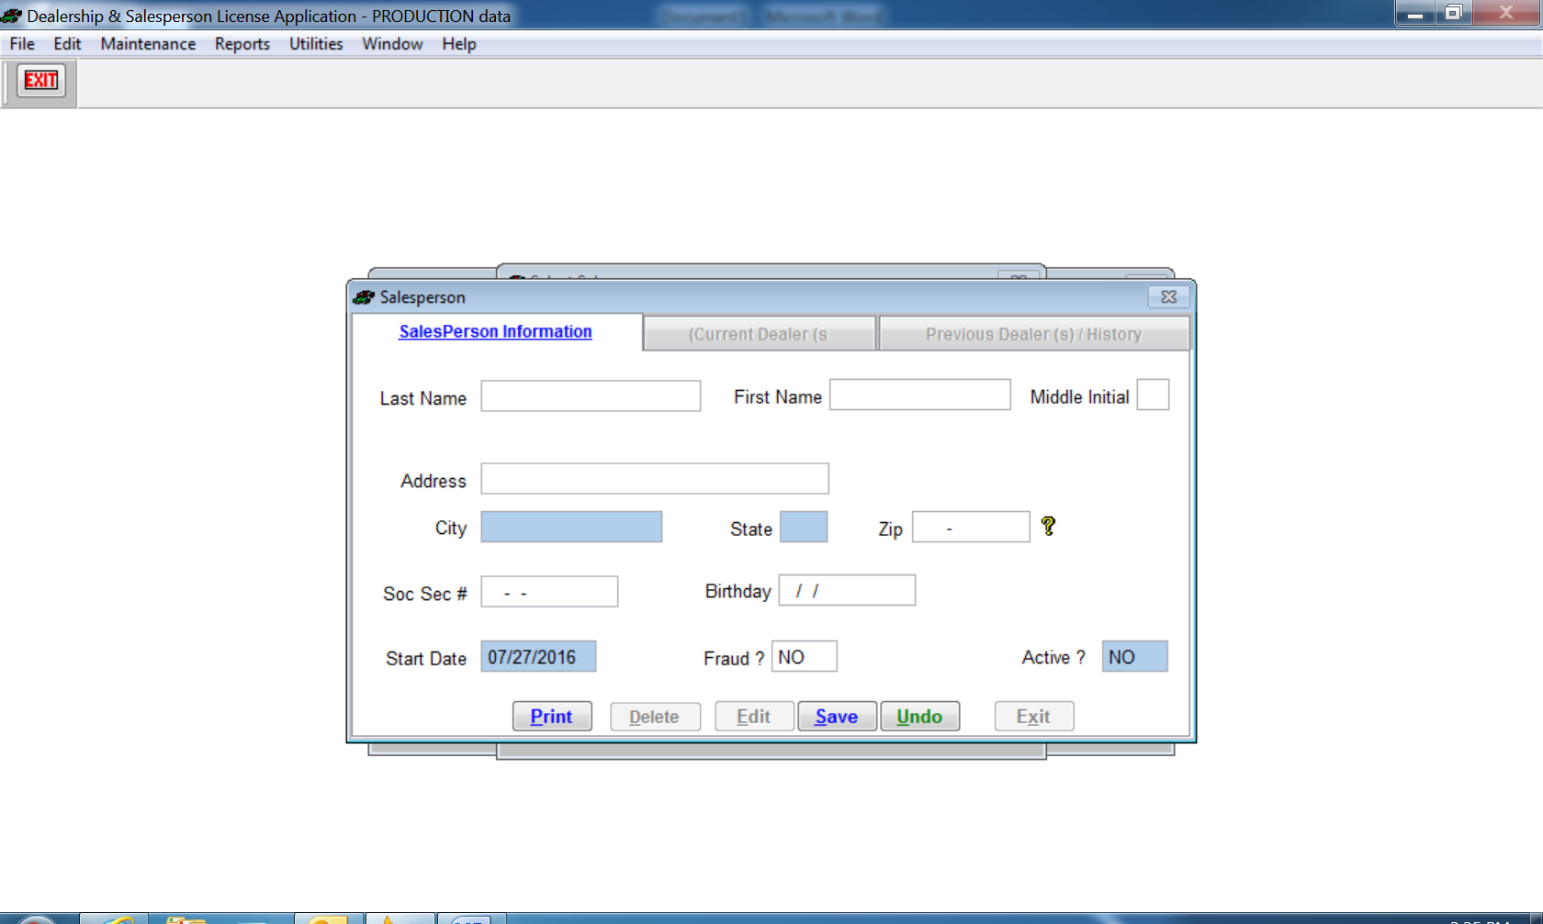
Salesperson, Representatives, Agents personal information is entered.
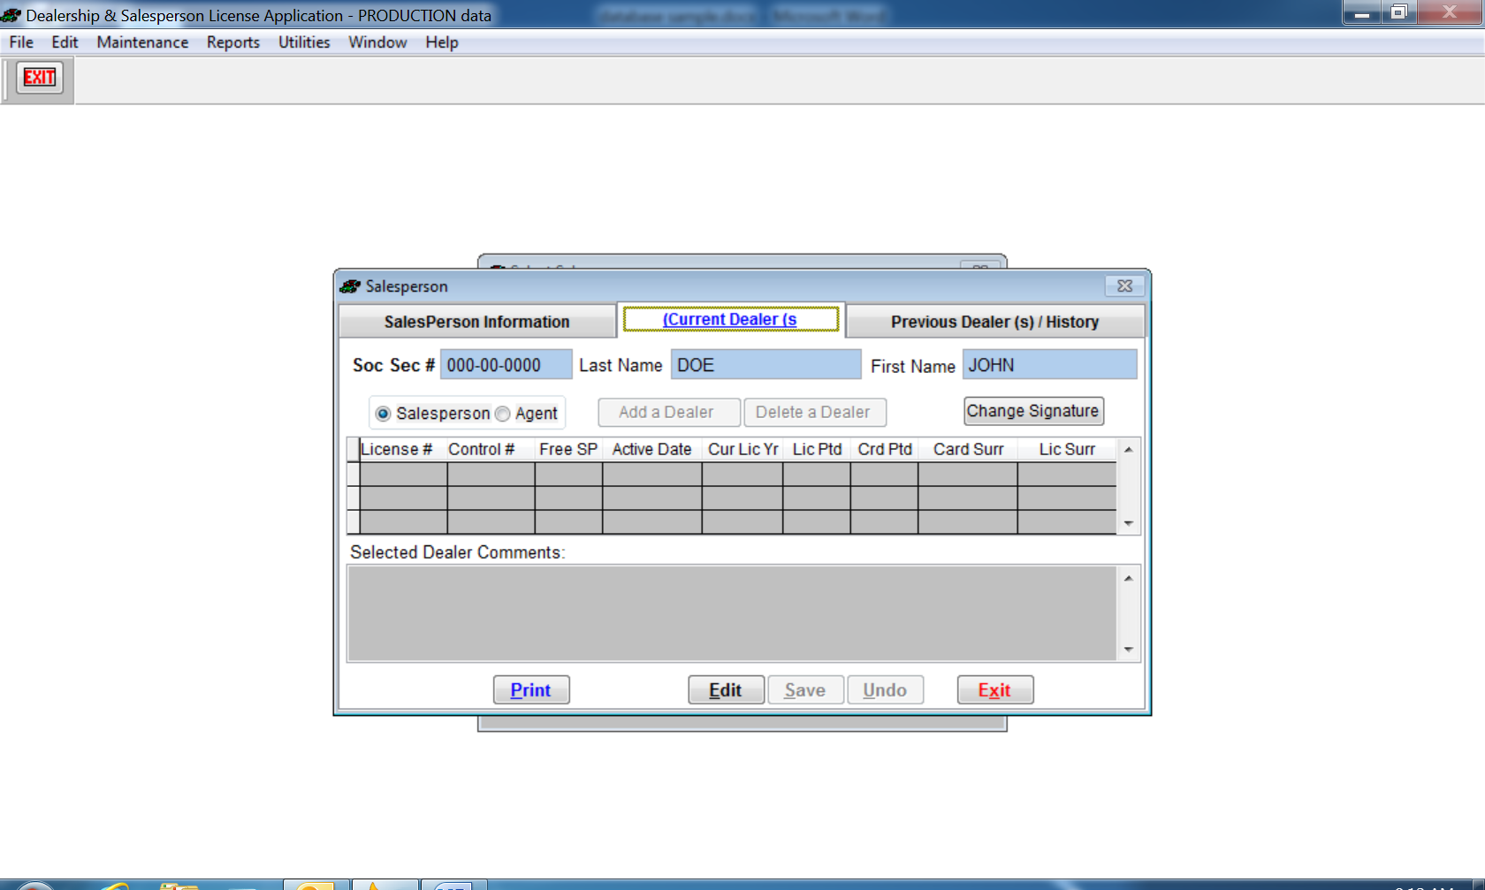
The Dealer License Number is added (License #) and the salesperson will appear on the dealer’s active sales staff list. If the License # begins with DS, MF, or MB, the license printed will indicate Representative and be recorded on the reconciliation report as a Representative. The control # will be recorded once the license prints.
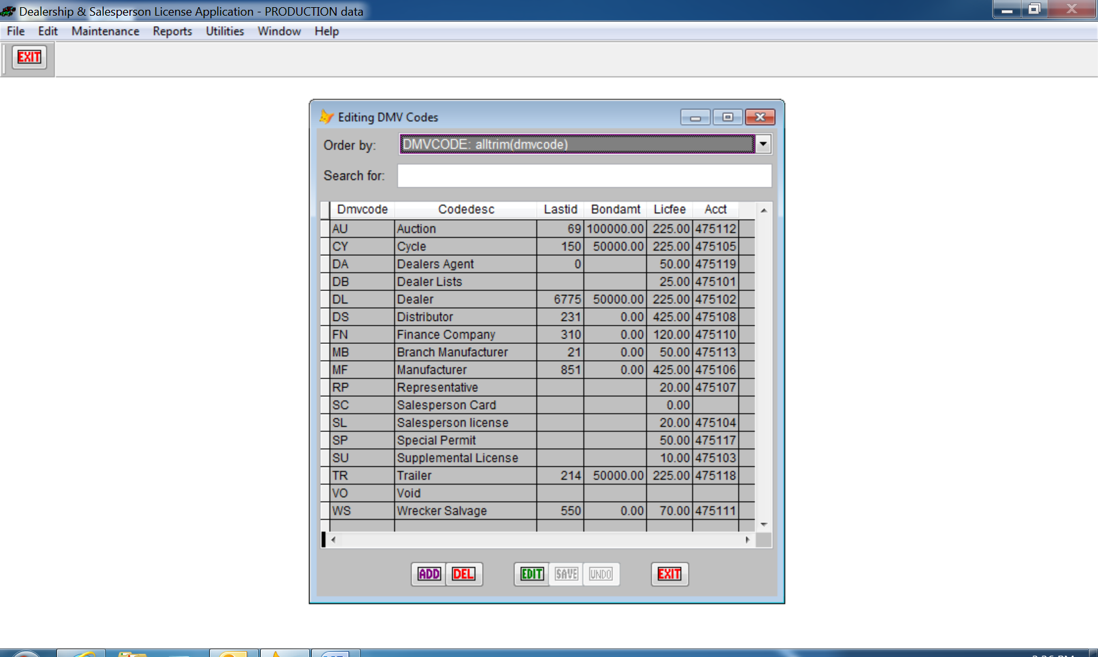
This table is used to assign the next license number for companies by type; the associated fee and account code for the reconciliation report.

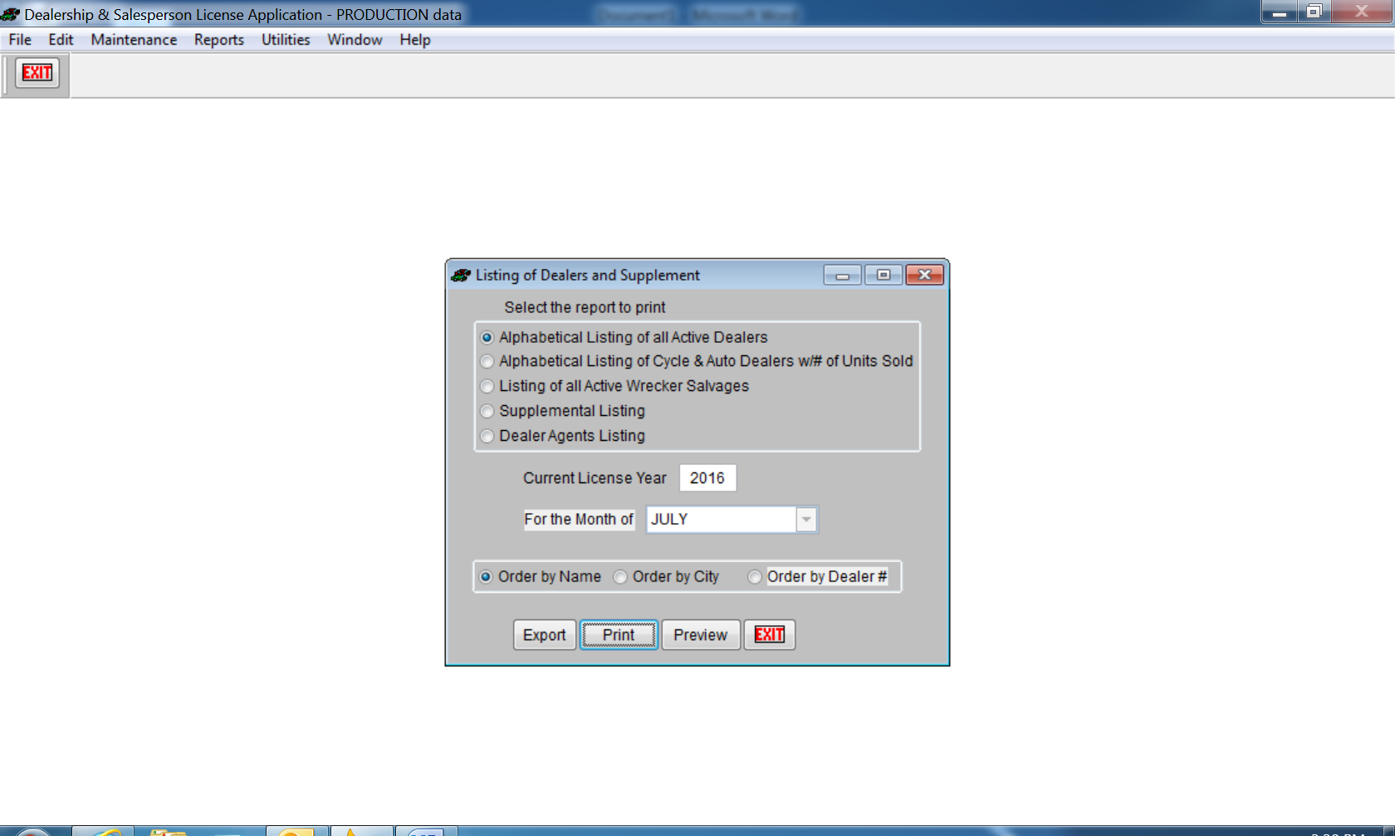
Reports of Licensed dealers may be created in pdf format or Excel format. Supplemental listing is may be saved as pdf.

